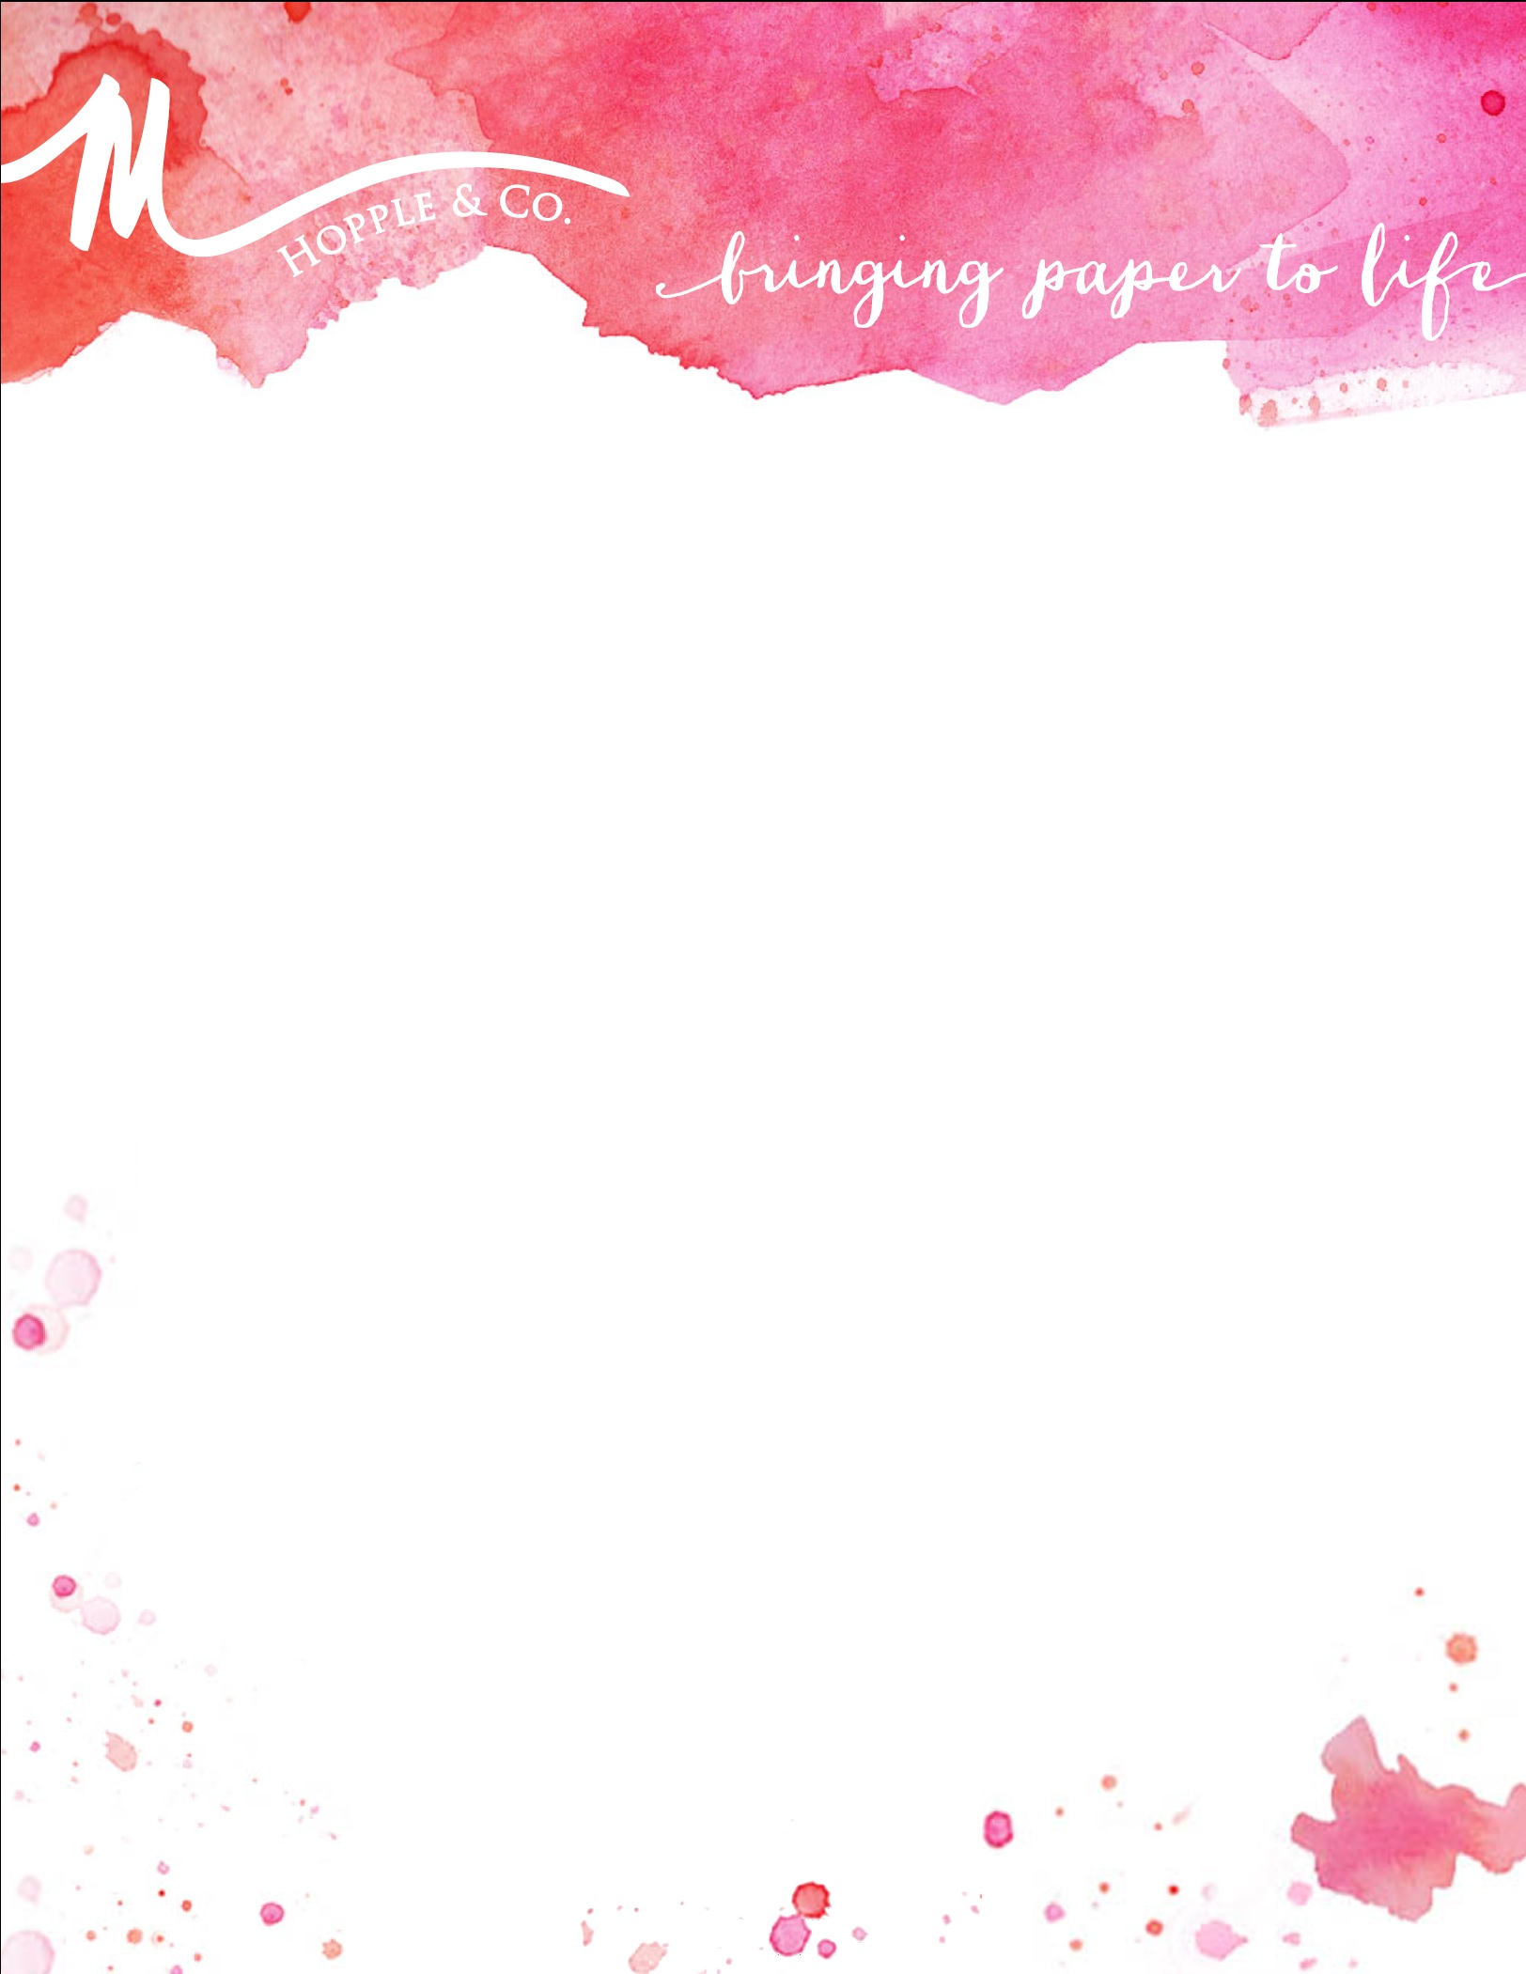

Bridal Information
How did you hear about M. Hopple & Co:
Bride’s Full Name:
 |  |  |  | First |  |  |  | Middle |  |  | Last
Email: |  |  |  |  |  |  |  |  | Phone:
Groom’s Full Name:
 |  |  |  | First |  |  | Middle |  |  | Last
Email: |  |  |  |  |  |  |  |  | Phone:
Contact Address:
 |  |  | Street Address |  |  |  |  |  |  |  |  |  |  |  |  |  |  | Apartment/Unit #
 |  | City |  |  |  |  |  |  |  |  |  |  | State |  |  |  | ZIP Code

Who is hosting the wedding?

Couple Bride’s Parents Groom’s Parents Both Sets of Parents
Name of Bride’s Parents:
 | Father’s First Name |  |  |  |  |  | Middle |  |  |  |  |  |  |  | Last
 |  | Mother’s First Name |  |  |  |  | Middle |  |  |  |  |  |  |  |  |  | Last
Name of Groom’s Parents:
 |  | Father’s First Name |  |  |  |  | Middle |  |  |  |  |  |  |  | Last
 |  | Mother’s First Name |  |  |  |  | Middle |  |  |  |  |  |  |  |  |  | Last

Wedding Details
Wedding Date: |  |  | Guest Count:
Time of Ceremony: |  |  | Venue:
Venue Address:
 | Street Address | City | State

Time of Reception: |  |  | Venue:
Venue Address:
 | Street Address |  |  |  |  |  | City | State

Meal Type (Check): Guest Choice Buffet Plated
Wedding Website: |  | Wedding Planner:

Wedding Aesthetics
Wedding Colors:

Wedding Theme (Check): Traditional Modern Vintage Whimsical Preppy Art Deco Rustic

Outdoors | Nautical | Destination: |  | Other:
Wedding Elements:
 | i.e. chevron, stripes, floral, damask, etc
Styles or Colors You Don’t Want:
Formality of Wedding (Check): |  | Black Tie Formal Semi-Formal Casual

